J-P Piirainen
“The sound of modern guitar and exotic Finnish kantele combined”

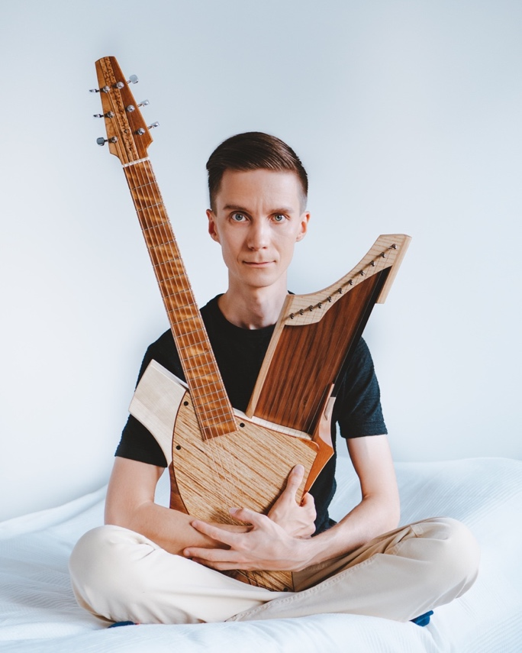

Hailing from Carelian forests in the eastern part of Finland, J-P Piirainen twines together Finnish tradition and his 2020 era unique voice as a composer. J-P has travelled unique path to discover music no one has heard before by inventing a one of a kind instrument- the guitele where acoustic guitar and the iconic traditional Finnish instrument the kantele are combined into one body. One of the most common and popular instruments in the world meets an instrument with an ancient legacy in Finnish tradition and mythology. His skills as a fingerstyle guitarist merges with the distinctive sound of the kantele creating an undiscovered world of music. J-P’s music creates images and soundscapes drawn from his native northern landscape.

“On first exploring the Guitele it felt like coming home, something was really familiar and at the same time it felt like being thrown into world you’ve never been before, one without a map. My mission is to discover that world with my new instrumental companion and find what kind of new and thus far undiscovered music that world has to offer. It’s like a blank canvas and my job is to paint it with music and stories.” – J-P Piirainen

www.jppiirainen.com
www.facebook.com/JPPiirainen.music
www.instagram.com/jppiirainen
www.youtube.com/channel/UCKvSRyGl2RRUhvDYPO1tqIQ

contact info:
jp@jppiirainen.com

